**Citi Bike Ride Findings**

1. Bike ridership increased late summer/early autumn
2. Age group 25-40 took the lowest duration on an average for the trip.

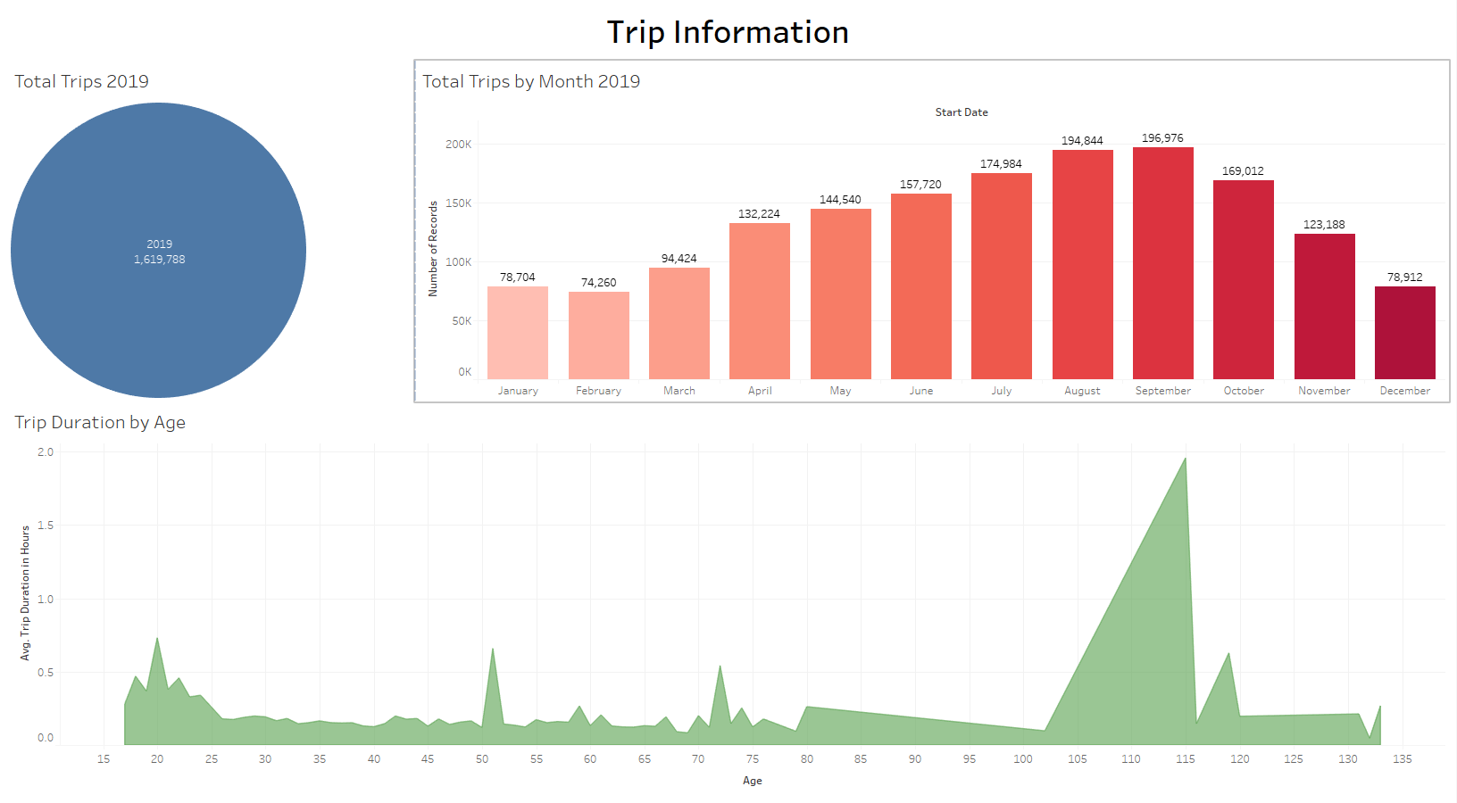

1. Subscriber contributes to more than 90% of the total number of riders to these rides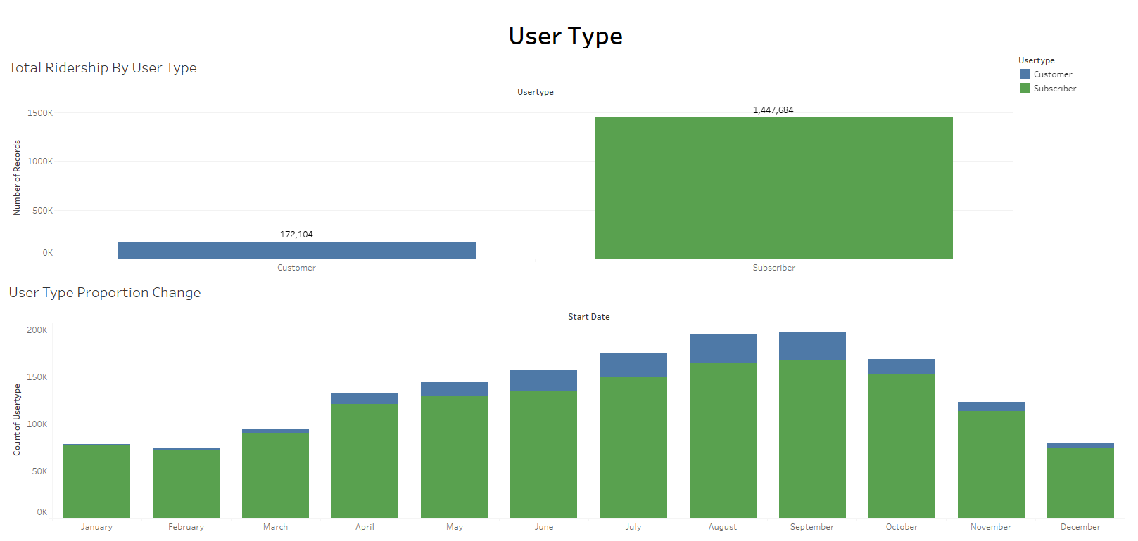
2. There is no change in the peak hours may it be summer or winter

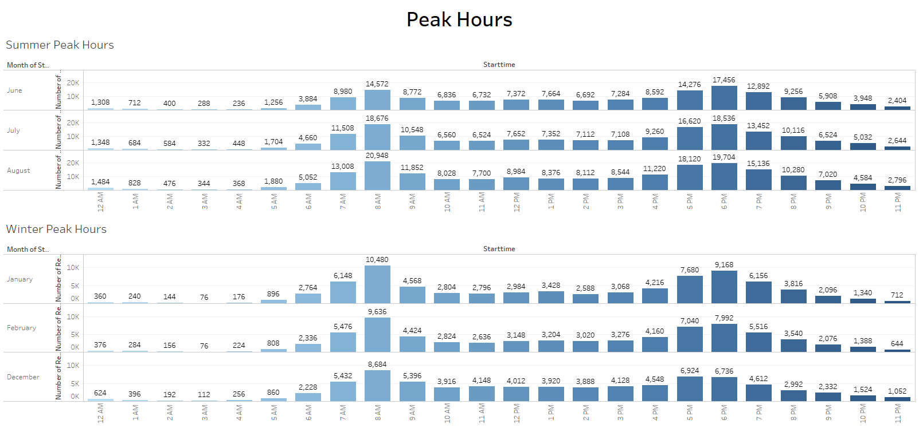

1. Males contribute more.

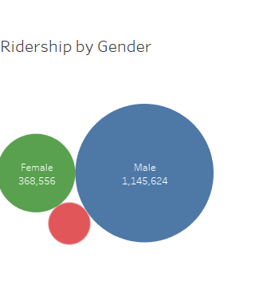

1. Female ridership has fluctuated over the years. It started approx. 16K in Jan and saw a dip in Feb to 15k. But, has seen an increase after that, though not a steep one. Mid Sep. had almost a total of 48K females but started decreasing after that. Hard to tell from the limited data what factors affect the ridership. We need to further expand the data over the years to see if that shows a clearer picture.

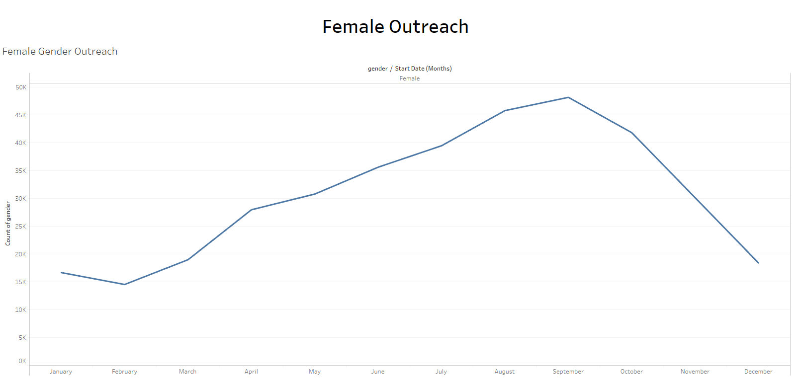

1. This shows that popularity does not mean that that a particular bike has been run for the longest number of hours.

